**PIZZA SALES REPORT**

1. Total Revenue Query:

select sum(total_price) as Total_Revenue from pizza_sales;

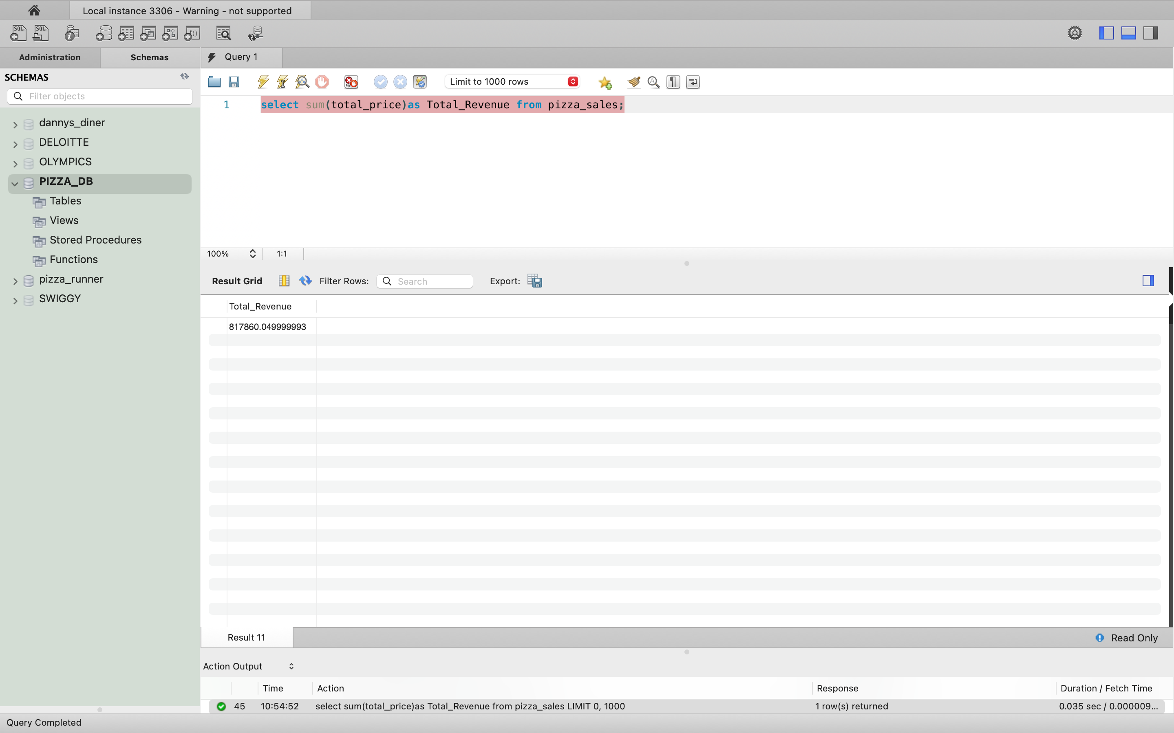

1. Average Order Value

select sum(total_price) / count(distinct order_id) as Average_order_Sales from pizza_sales;

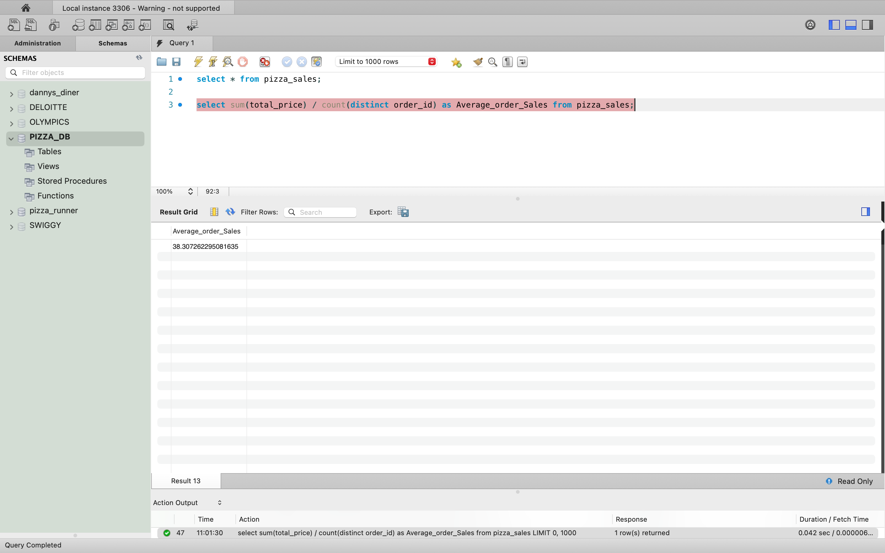

1. Total Pizzas sold.

select sum(quantity) as Total_Pizza_Sold from pizza_sales;

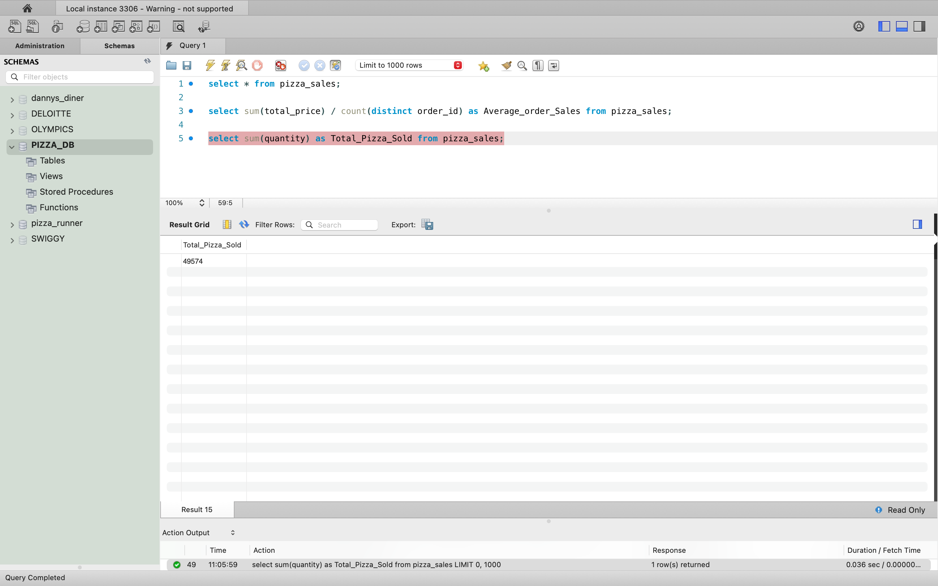

1. Total_order_placed.

select count(distinct order_id) as Total_order_placed from pizza_sales;

